What type of Jack-o-lantern do you like better?

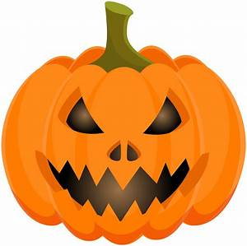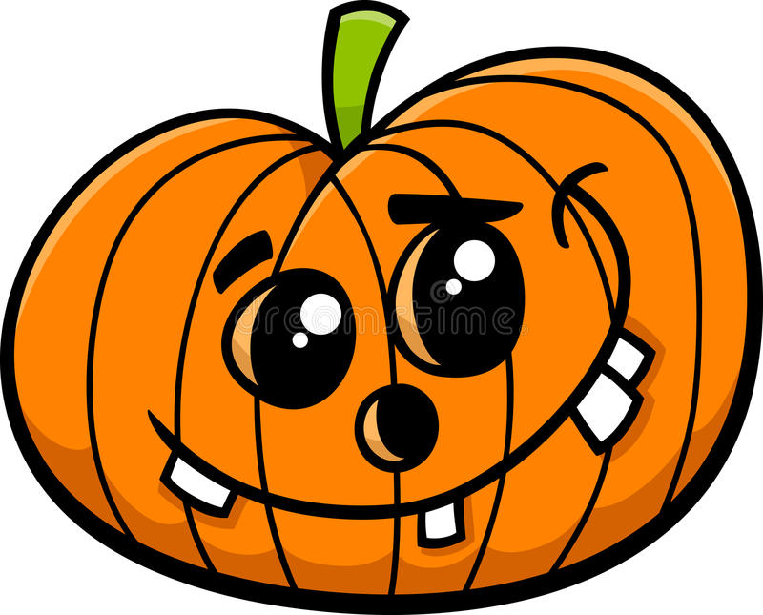
Spooky Silly

Do you have any pumpkins around your house? Show Miss Ashley a picture of you and a pumpkin if you have one.

