The color of the month last month was yellow.
We did a fun craft painting with lemons.

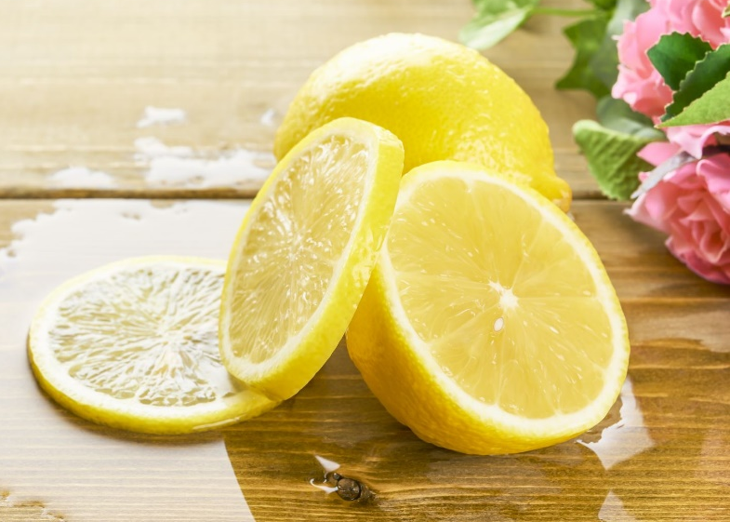
What color are lemons?
Yellow or Blue
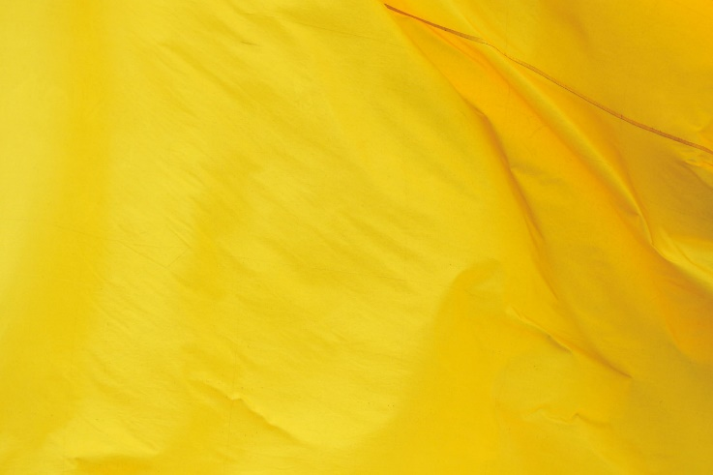

Send Miss Ashley a picture of you holding something yellow.

